Assignment #7: Resonance

O C T A V E N U M B E R
 | 0 | 1 | 2 | 3 | 4 | 5 | 6 | 7 | 8
C | 16.35 | 32.70 | 65.41 | 130.81 | 261.63 | 523.25 | 1046.50 | 2093.00 | 4186.01
C# | 17.32 | 34.65 | 69.30 | 138.59 | 277.18 | 554.37 | 1108.73 | 2217.46 | 4434.92
D | 18.35 | 36.71 | 73.42 | 146.83 | 293.66 | 587.33 | 1174.66 | 2349.32 | 4698.64
D# | 19.45 | 38.89 | 77.78 | 155.56 | 311.13 | 622.25 | 1244.51 | 2489.02 | 4978.03
E | 20.60 | 41.20 | 82.41 | 164.81 | 329.63 | 659.26 | 1318.51 | 2637.02 | 5274.04
F | 21.83 | 43.65 | 87.31 | 174.61 | 349.23 | 698.46 | 1396.91 | 2793.83 | 5587.65
F# | 23.12 | 46.25 | 92.50 | 185.00 | 369.99 | 739.99 | 1479.98 | 2959.96 | 5919.91
G | 24.50 | 49.00 | 98.00 | 196.00 | 392.00 | 783.99 | 1567.98 | 3135.96 | 6271.93
G# | 25.96 | 51.91 | 103.83 | 207.65 | 415.30 | 830.61 | 1661.22 | 3322.44 | 6644.88
A | 27.50 | 55.00 | 110.00 | 220.00 | 440.00 | 880.00 | 1760.00 | 3520.00 | 7040.00
A# | 29.14 | 58.27 | 116.54 | 233.08 | 466.16 | 932.33 | 1864.66 | 3729.31 | 7458.62
B | 30.87 | 61.74 | 123.47 | 246.94 | 493.88 | 987.77 | 1975.53 | 3951.07 | 7902.13

- A guitar has a string that is tuned to E₄. If the length of the string is 0.65m, what is the speed of sound in the string?

- You are trying to play Mary Had a Little Lamb by blowing across the top of glass soda-bottles. The speed of sound in air is 343 m/s. The notes you will need are B7, A7, G7 and D8. How long would the column of air in each soda bottle need to be in order to play the song?

- A trombone has a length of 2.743 m, and produces an A#2 at its first fundamental resonance.
  - What is the speed of sound in brass? (Wind instruments are open-tubes)

  - What is the wavelength of the second harmonic?

  - What note is the second harmonic closest to?

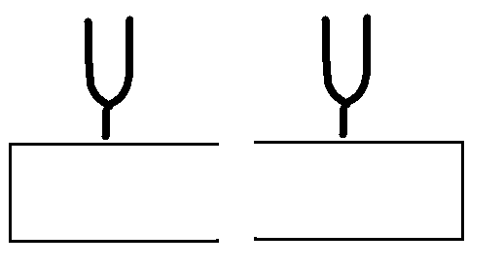
- Two tuning forks are placed on empty wooden boxes. Both tuning forks are pitched at middle-C (C₅). What should the size of each box be in order for the second tuning fork to resonate when the first one is struck?

- A 1024 Hz tuning fork is struck over a tube that is placed in a bucket of water.
  - How much of the tube needs to be above water for the tube to be in its fundamental resonance mode?

  - Calculate the lengths the tube would need to be if it was resonating in the n=2, n=3 and n=4 modes.

- The Tacoma Narrows bridge collapsed due to resonance driven by the wind. The period of the wave was about two seconds, and the length of the resonant section of the bridge was 100 meters, and the bridge resonated at the second harmonic.
  - What was the wavelength of the wave?

  - What was the speed of the wave in the bridge?

